**DAILY ONLINE ACTIVITIES SUMMARY**

|  |  |  |  |  |  |  |  |  |
| --- | --- | --- | --- | --- | --- | --- | --- | --- |
| **Date:** | 21-06-2020 | | | | | **Name:** | D Richard Franklin | |
| **Sem & Sec** | Fourth sem section A | | | | | **USN:** | 4AL18CS020 | |
| **Online Test Summary** | | | | | | | | |
| **Subject** | | N/A | | | | | | |
| **Max. Marks** | | - | | **Score** | | | - | |
| **Certification Course Summary** | | | | | | | | |
| **Course** | 1. **Microsoft Azure** | | | | | | | |
| **Certificate Provider** | | | greatlearning | | **Duration** | | | 3 hr |
| **Coding Challenges** | | | | | | | | |
| **Problem Statement:**  1: [Program that compares counting words in files using an ArrayList and a Map](https://github.com/orgs/alvas-education-foundation/teams/2nd-year/discussions/131) | | | | | | | | |
| **Status:** completed | | | | | | | | |
| **Uploaded the report in Github** | | | | | yes | | | |
| **If yes Repository name** | | | | | <https://github.com/alvas-education-foundation/Richard_Franklin> | | | |
| **Uploaded the report in slack** | | | | | yes | | | |

**Online Test Details: N/A**

**Online Course Details:**

1. Name of course: **Microsoft Azure essentials**

Certificate provider: greatlearning

The total course was about how we can get thorough with what Microsoft azure is and how it’s beneficial in the branch of cloud computing. Today I went through the Azure devops and how the cloud security works with Azure.

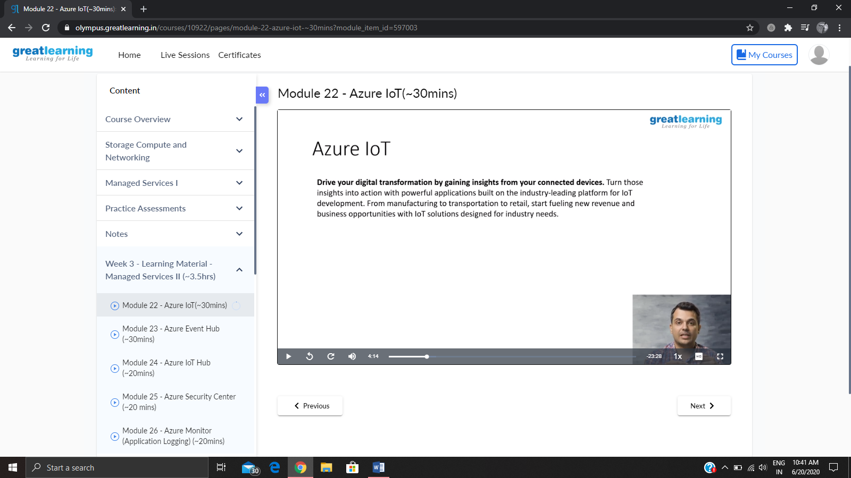

**Online coding:**

Problem 1: (using JAVA) [Program that compares counting words in files using an ArrayList and a Map](https://github.com/orgs/alvas-education-foundation/teams/2nd-year/discussions/131)

